**QSMART – WARRANTY LABELS PLACEMENT**

**PROCEDURE**

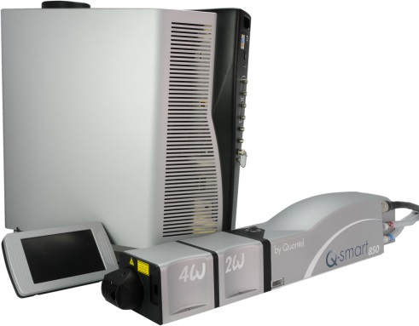

**Outils:**

Allen keys

**Systeme**: QSMART

**Purpose**: This document details where to place the warranty labels on the laser head

|  |  |  |
| --- | --- | --- |
| Revision | date | modification |
| Initial issue | July 4, 2014 |  |
|  |  |  |
|  |  |  |
|  |  |  |

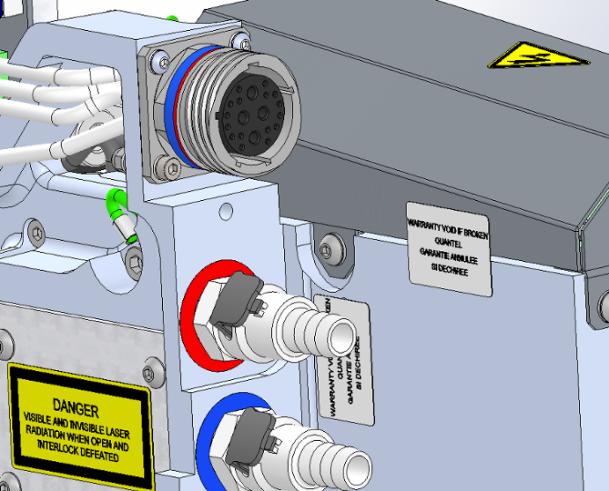

4 warranty labels 3/ATC/0185

